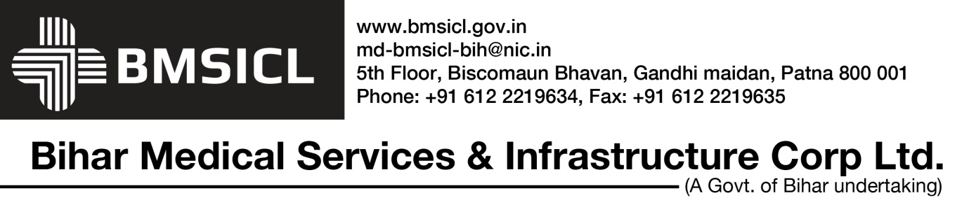

Corrigendum Notice No.-1, Dated:- 02/01/2018
Ref. N.I.T. No. BMSICL/Infra/38/2017 Dated-22.11.2017

NOTICE INVITING TENDER
For Construction of Government Medical College, Purnea, Dist-Purnea, Bihar

- The Revised tender schedule is as follows:-

Sl. No. | Activity | Date
1. | Period of Sale of Tender document (Download) | From 03.01.2018 at 10:00 hrs.
 |  | To 24.01.2018 upto 15:00 hrs. on (www.eproc.bihar.gov.in)
2. | Date, Time and Place of Pre-Bid meeting | 11.01.2018 at 11.00 hrs. in the office of BMSICL.
3. | Last Date and time for receipt (upload) of Tender | 25.01.2018 upto 15:00 hrs. on website (www.eproc.bihar.gov.in)
4. | Date/Time for submission of Original/Hard Copy of Tender Fee, EMD and Tender documents. | 29.01.2018 upto 15.00 hrs. in the office of BMSICL.
5. | Date/Time and Place for Opening of Tender | 29.01.2018 at 15.30 on (www.eproc.bihar.gov.in) in the office of BMSICL.
6. | Date/Time and Place for Opening of Financial Bid | To be informed later.

- The other Terms & Condition will remain same.

G.M. (P&D)
BMSICL, Patna

